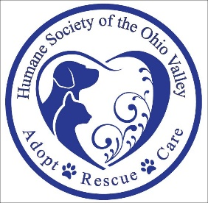

Want to Help Homeless Animals? ….
Sponsor the 17th Annual Fur Ball

Dear Friend,

The Humane Society of the Ohio Valley (HSOV) will hold the 17th Annual Fur Ball on March 28, 2020, at the Shrine Club in Marietta, Ohio from 7:00 p.m. until Midnight. Fur Ball attendees are treated to an evening of live entertainment, great food and the opportunity to bid on fabulous prizes.

This is our main fundraising event each year so that we can continue to help local animals in need, like Arlo.

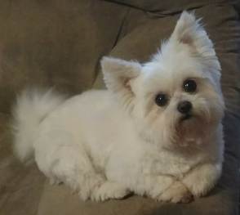
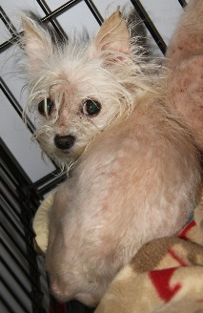
Arlo was living in deplorable conditions with twelve other animals when he was brought to HSOV in June. Though he was neglected, filthy and missing a tremendous amount of hair; he was the sweetest little guy you would ever meet. A couple at HSOV volunteered to foster him but after taking him in, they fell so head over heels in love that they decided to adopt instead! Now, with proper diet and grooming, patience, and lots of love, his “rags to riches” transformation has been incredible.
After
Before
Arlo

What a heartwarming story with a happy ending!

We are so proud to care for scared animals like Arlo when they have nowhere else to turn. In addition to seeking loving, permanent homes for companion animals, HSOV also operates with the following priorities:
- To Provide Spay and Neuter Assistance Programs
- To Work Actively to Prevent and Address Animal Cruelty
- To Educate the Public About Humane Issues

But it takes an average of $9,400.00 a month in medical costs alone to care for dogs like Arlo and all the other animals that come through the door. Sometimes, we simply don’t have the funds.

This is why we’re asking you to please consider becoming a supporter of the HSOV 17th Annual Fur Ball in one of the following ways:

- Sponsorship – Enclosed you will find a flyer showing the sponsorship levels
- Donations – We will be accepting donations of items, gift cards, tickets, etc. to be used in Country Store and
Live Auction

Thanks in Advance!
Humane Society of the Ohio Valley
90 Mount Tom Road
Marietta, OH 45750

P.S. As a 501(c)3 nonprofit organization, your donation is tax deductible and will make a difference in the lives of the animals that enter our shelter. Tax ID #31-4393873
17th Annual Fur Ball
March 28, 2020
Shrine Club, Marietta, OH 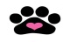 7:00 p.m. – Midnight

SPONSORSHIP OPPORTUNITIES
Man’s Best Friend Puppy Love Purrfect Partner
$3,000.00 $1,000.00 $500.00
(Provides Spay/Neuter for 30 Animals) (Provides Spay/Neuter for 10 Animals) (Provides Spay/Neuter for 5 Animals)
8 Reserved Ticket to Event 4 Reserved Tickets to Event 2 Reserved Tickets to Event
2 50/50 Tickets Per Person 1 50/50 Ticket Per Person Logo on Event Banner*

2 Buckets of Beer 1 Bucket of Beer Web page Acknowledgement

Logo on Event Banner* Logo on Event Banner* Facebook Acknowledgement
(Over 23,000 Followers)
Included on Media Advertising Web Page Acknowledgement
HSOV/Event Memorabilia
Web Page Acknowledgement Facebook Acknowledgement
(Over 23,000 Followers)
Facebook Acknowledgement
(Over 23,000 Followers) HSOV/Event Memorabilia

HSOV/Event Memorabilia

YES! I am willing to participate at ____________________________________________________ level.
Company Name: _______________________________________ Contact: ________________________
Address:________________________________________________________________________________
Email: _______________________________________ Phone No. ________________________________

I do not wish to participate at one of the sponsorship levels, but want to donate in the amount of $ _________.
Name Included on Event Banner*
$250 (Providing Vaccinations for 7 Animals)
$100 (Providing Vaccinations for 3 Animals)
$50 (Providing Vaccinations for 1 Animal)

Sponsorships can be made in one of the following ways:
By Check - Mail to: HSOV 90 Mount Tom Road, Marietta, OH 45750
By Credit Card - Visit hsov.org via Fur Ball Hotspot or Call 740-373-5959

* If sponsorship is received by Monday, March 16, 2020

